What’s a Video Room?
A new solution for virtual and hybrid interaction
For an event organizer who needs to provide opportunities for attendees to interact in real time, virtual and hybrid events are a challenge.
The good news is, Socio has risen to the challenge and is providing a feature that can be added to your event that allows participants to not only type messages to each other (chat) but to talk face-to-face with as many as 9 other people, including up to 3 moderators.
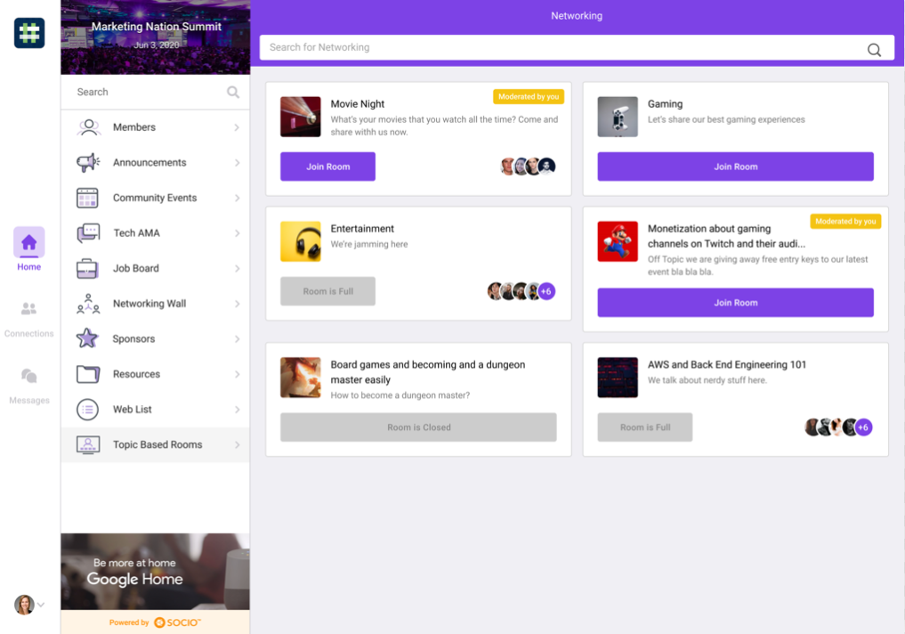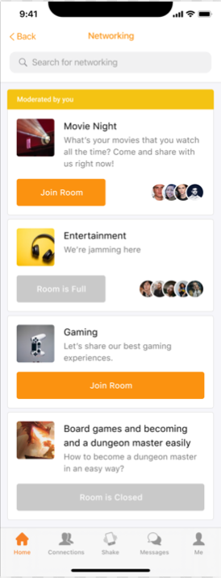
When your event attendees enter the Video Room feature, whether on the Web or Mobile App, they’ll be able to choose from all the rooms in your event, which can be distinguished by topic or title. Moderators will see the Moderated by You tag where appropriate.
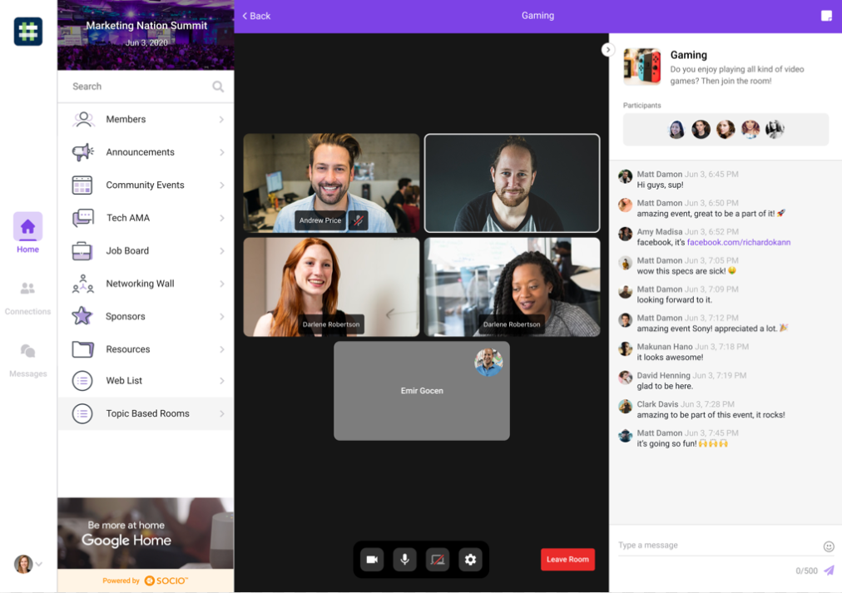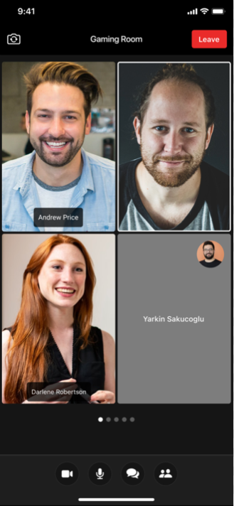
Once in the room, attendees have no time limit to be able to talk and/or chat with other participants, see the chat history for the room, and see a list of participants. They can share their screen (if they’re using the Web App) and even add participants as a connection without leaving the room.
But what about you as the event organizer? You can create a chat export, similar to our other features, and a participant export showing who joined a room and when they joined. Rooms can be internally linked and, on a feature level, Visible To is supported.
But best of all, you’ll know you are providing a beneficial and attractive tool to the participants of your event, making them glad to have attended.
Check out this Feature Guide for detailed information on adding the Video Room feature to your event.

